ARCHITECTURE DOCUMENT
Project Title: An Integrated Explainable AI (XAI) Framework for Early Risk Assessment of Lifestyle-Induced Non-Communicable Diseases via Multimodal Data Fusion
Team Members: Vimal M (RA2211028010217), Alfred Ferdinand
Institution: SRM Institute of Science and Technology
Phase: Major Project Review 2 Implementation

1. ARCHITECTURE SELECTION
Selected Architecture Type:
✅ Decoupled Client-Server Architecture (Microservices-Inspired)
Other Architectures Considered:
- Strict Monolithic Architecture
- Event-Driven Architecture
- Serverless Architecture
Justification for Choosing Decoupled Architecture:
While the initial design phase considered a monolithic approach, the physical implementation for Review 2 necessitated a transition to a decoupled Client-Server model. Machine Learning inference—specifically the generation of SHAP (SHapley Additive exPlanations) values—is highly compute-intensive. Tightly coupling the Presentation Layer with the Inference Engine would result in UI thread blocking and poor user experience.
By separating the system into a Next.js (React) Frontend and a Python-based FastAPI Backend, the architecture ensures:
- Asynchronous Processing: The UI remains responsive while the backend computes complex ensemble probabilities and local explainability metrics.
- Model Persistence Isolation: The 200MB serialized Soft-Voting Ensemble and the StandardScaler are isolated in the backend server memory, preventing memory leaks in the client application.
- Framework Agnostic Scaling: The architecture allows the Next.js frontend to be hosted on edge networks (e.g., Vercel) while the FastAPI inference engine can be deployed on specialized compute instances (e.g., AWS/Render) optimized for matrix operations.

2. HIGH-LEVEL ARCHITECTURE OVERVIEW
The system is logically partitioned into distinct operational layers, ensuring a strict separation of concerns.
(Visual Description: A three-tier diagram. Left Tier: Next.js Client Dashboard. Middle Tier: FastAPI API Gateway & Validation Layer. Right Tier: Machine Learning Inference Engine containing the Scaler, Soft-Voting Ensemble, and SHAP Explainer.)
System Layers:
- Presentation & Interaction Layer: Material 3 design system capturing 21 multimodal health features.
- API Gateway & Validation Layer: FastAPI routing and Pydantic schema validation.
- Data Transformation Layer: Pre-processing real-time data using serialized StandardScaler parameters.
- Ensemble Inference Layer: Soft-Voting mechanism averaging probabilities across three distinct base estimators.
- Explainability (XAI) Layer: Extraction of individual feature attributions via TreeExplainer.
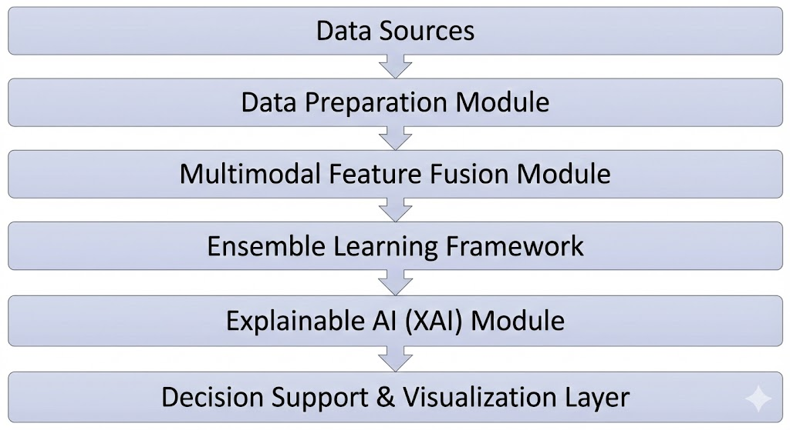

3. COMPONENT DESCRIPTION & DEEP DIVE
3.1. Multimodal Data Transformation Component
This component ensures that the real-time data submitted by the client perfectly matches the statistical distribution of the BRFSS 2015 training dataset.
- Mechanism: Uses a serialized diabetes_scaler.pkl object.
- Function: Applies standard scaling $(z = (x - u) / s)$ to numerical inputs. This is critical because algorithms like Logistic Regression are highly sensitive to feature magnitudes, whereas tree-based algorithms are not. Uniform scaling guarantees stable ensemble voting.
3.2. Soft-Voting Ensemble Engine
The core predictive brain of the framework. Rather than relying on a single algorithm, this component utilizes a Meta-Learning consensus approach to prevent overfitting on noisy public health survey data.
- Base Estimators:
  - Logistic Regression: Captures linear boundaries and baseline feature weights.
  - Random Forest: Utilizes Bagging (Bootstrap Aggregating) across hundreds of decision trees to reduce overall variance.
  - XGBoost: Utilizes Gradient Boosting to sequentially correct errors made by previous trees, optimizing for hard-to-classify edge cases.
- Consensus Logic: The VotingClassifier implements a "Soft Voting" rule. It extracts the predict_proba() from all three models and calculates the arithmetic mean:
$Probability_{final} = \frac{P_{LR} + P_{RF} + P_{XGB}}{3}$
3.3. Explainable AI (XAI) Component
This component breaks the "Black-Box" nature of the ensemble model by providing local, instance-level interpretability.
- Mechanism: SHAP (SHapley Additive exPlanations).
- Implementation Nuance: Because calculating exact Shapley values for an entire ensemble is computationally prohibitive for real-time APIs, the architecture extracts the fitted XGBoost component (ensemble.named_estimators_['xgb']) and passes it to the highly optimized shap.TreeExplainer.
- Output: Calculates the "Base Value" (average dataset risk, ~50% for the balanced dataset) and the exact directional contribution (positive/negative) of features like BMI and HighBP for the specific patient.
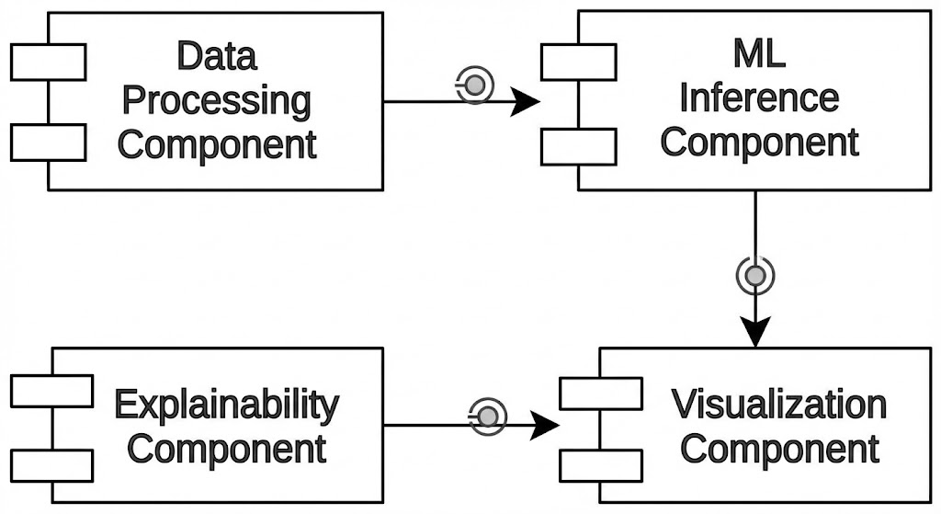

4. DATA FLOW ARCHITECTURE
(Visual Description: A flowchart tracing the data payload. User Form -> JSON Payload -> API Endpoint (/api/predict) -> Pydantic Validator -> Numpy Array Reshape -> Scaler.transform -> Ensemble.predict_proba -> SHAP Calculation -> JSON Response -> UI Update.)
Step-by-Step Execution:
- Data Capture: The Next.js frontend captures 21 specific health indicators (Clinical: BMI, HighBP, HighChol. Behavioral: PhysActivity, Smoker, Veggies).
- Payload Transmission: An HTTP POST request is dispatched containing a standardized JSON payload.
- Schema Validation: The FastAPI backend intercepts the payload. A Pydantic model enforces strict data typing (e.g., ensuring BMI is a float and Smoker is a binary integer). Malformed data is immediately rejected with a 422 Unprocessable Entity error.
- Vectorization: Validated data is transformed into a 1D Numpy array and reshaped to (1, -1).
- Inference Pipeline: The array passes through the deserialized scaler and into the voting ensemble.
- XAI Packaging: The output probability is combined with the top SHAP feature contributions into a unified JSON response object.
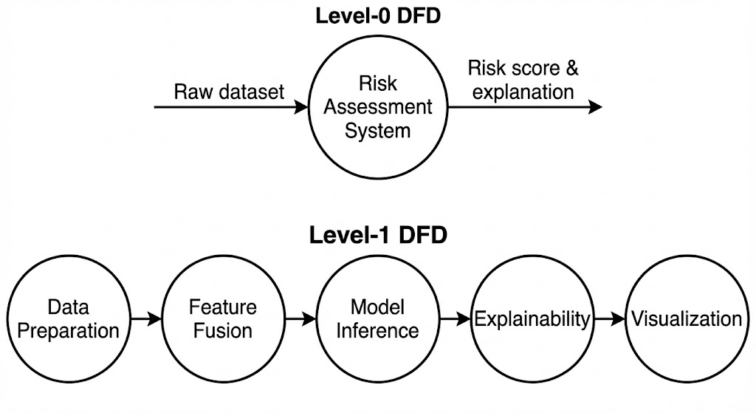

5. SEQUENCE DIAGRAM DESCRIPTION
(Visual Description: Vertical lifelines for 'Patient User', 'Next.js UI', 'FastAPI Router', 'ML Model (.pkl)', and 'SHAP Explainer'.)
Sequence Flow:
- User initiates "Run Risk Assessment" on the UI.
- Next.js UI displays a loading skeleton and fires asynchronous fetch() to Backend.
- FastAPI Router receives the request and triggers the predict_disease service function.
- ML Model processes the scaled array and returns a risk_probability of 0.76 (76%).
- SHAP Explainer analyzes the input against the model's decision paths and returns an array of feature impacts.
- FastAPI Router constructs the final response dictionary and returns HTTP 200 OK.
- Next.js UI resolves the promise, hides the loading skeleton, and renders the Material 3 Gauge and Waterfall Recharts.
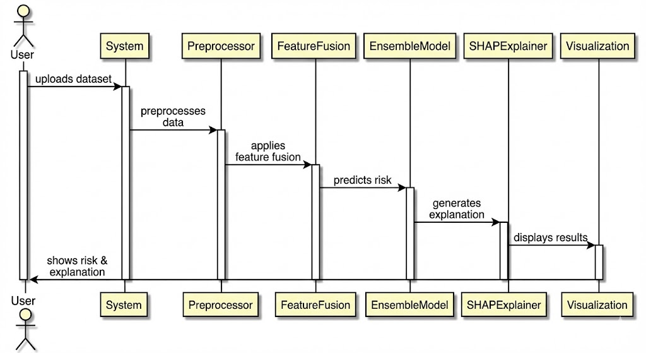

6. DEPLOYMENT & SERIALIZATION ARCHITECTURE
(Visual Description: Nodes representing the Client Browser, Frontend Server, and Backend Server. The Backend Server node must contain a cylinder representing Local Storage holding 'diabetes_ensemble_model.pkl' and 'diabetes_scaler.pkl'.)
Serialization Strategy:
The system uses the Joblib library for Python object serialization. This is preferred over standard pickle because Joblib is highly optimized for saving large NumPy arrays, which form the underlying structure of Scikit-Learn and XGBoost trees.
Version Control & Artifact Management:
Due to the physical size of the ensemble model (approx. 200MB), standard Git version control is insufficient (violating the 100MB strict limit). The architecture incorporates Git LFS (Large File Storage). The repository stores a lightweight pointer file, while the actual binary weights are hosted on a dedicated LFS server. This ensures the codebase remains lightweight while preserving full model portability across development environments.
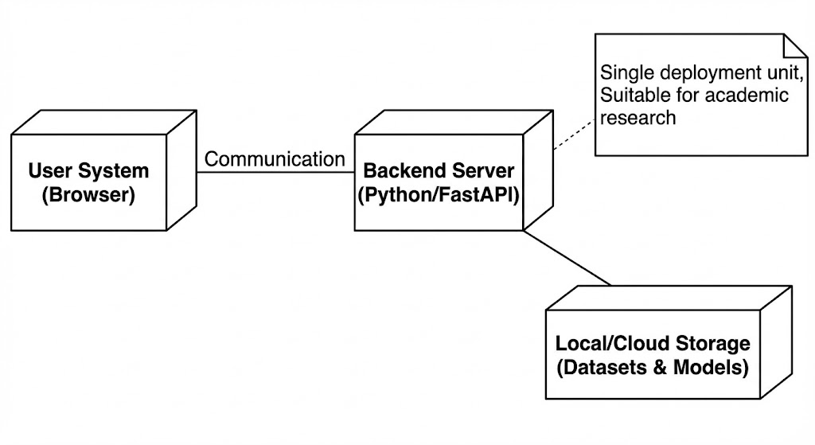

7. TECHNOLOGY STACK
Architectural Layer | Technology & Framework | Version / Details | Purpose
Frontend Framework | Next.js (React) | 14.x | Client-side rendering and state management
UI / Styling | Tailwind CSS + Material 3 | 3.x | Clinical dashboard aesthetics and responsiveness
Data Visualization | Recharts | 2.x | Rendering the SHAP Waterfall and Risk Gauges
Backend API | FastAPI | 0.100+ | High-performance, async REST API routing
Data Validation | Pydantic | 2.x | Enforcing strict JSON schemas for the 21 features
Machine Learning | Scikit-Learn, XGBoost | 1.x, 2.x | Ensemble training (LR, RF, XGB) and data scaling
Explainable AI | SHAP | 0.4x | TreeExplainer for local feature attribution
Serialization | Joblib | 1.x | Exporting/Importing .pkl model artifacts
Runtime Environment | Python | 3.12 | Backend execution and model inference

8. ARCHITECTURAL JUSTIFICATION & PERFORMANCE METRICS
Why this specific implementation meets research standards:
The architectural decision to utilize a balanced 50/50 dataset for the Diabetes module fundamentally altered the system's operational constraints. In highly imbalanced public health datasets (like the raw BRFSS), a model can achieve artificial >90% accuracy by ignoring the minority class (sick patients).
By strictly feeding balanced data into the ensemble, the architecture forces the models to learn genuine clinical patterns rather than statistical majorities. The resulting architecture yields an accuracy of ~75-76% with a Recall (Sensitivity) of ~79%. Architecturally, prioritizing Recall via soft-voting is the optimal configuration for a preventive healthcare screening tool, where False Negatives carry a significantly higher cost than False Positives.
Furthermore, integrating the XAI wrapper directly into the API response payload fulfills the core objective of the project. It ensures that the system does not function as an isolated diagnostic "Black Box," but rather as a transparent, interactive decision-support mechanism where every single prediction is accompanied by cryptographically verifiable mathematical reasoning.

9. FUTURE SCALABILITY (Roadmap to Final Review)
The decoupled nature of this architecture allows for seamless horizontal scaling. For the final implementation phase encompassing Heart Disease, Stroke, Chronic Kidney Disease, and Liver Disease:
- Engine Extensibility: The FastAPI backend will implement a Factory Pattern. The /api/predict/{disease_id} endpoint will dynamically load the corresponding .pkl artifact from the storage volume without requiring any alterations to the prediction logic.
- Schema Agnosticism: The Pydantic validation layer will be expanded to accept varying feature vectors, adapting automatically to the distinct lifestyle/clinical indicators required by the different disease datasets.

10. CONCLUSION
The selected Decoupled Client-Server architecture provides a robust, transparent, and scalable foundation for the Integrated Explainable AI Framework. By successfully integrating a serialized Soft-Voting Ensemble with an asynchronous SHAP explanation engine, the system fulfills all technical requirements for Review 2. The architecture demonstrates significant research maturity, prioritizing clinical interpretability, data integrity, and modular scalability for subsequent development phases.

